Dear Parent/Carer
Can we interest you in the role of Parent Governor?
Last year, the Victoria Primary and Ebor Gardens Governing Body was managed by a small executive group. This year, we are establishing a brand-new Governing Body to see the schools into the next phase of their development.
These are exciting times for Victoria and Ebor Gardens, and we are very much looking forward to working with a newly formed body to shape the future of our schools.
Parent Governors bring an important, local perspective to Governing Body discussions and decision making and are key to successfully gathering a group of diverse people who all want the same thing – great schools for great children.
The three key roles of a GB in any school/academy are to:
• ensure that it has a clear vision, ethos, and strategic direction
• oversee the financial performance of the school/academy
• monitor the educational performance of the school/academy.
If you feel you could give up some time to undertake the role and would like to find out more about what it involves, please contact Sam Corbett, Governance Manager for Wellspring Academies Trust. Sam is contactable on 01226 720741 or by email s.corbett@wellspringacademies.org.uk. Sam will also talk you through the application process, which is very straightforward. The closing date for applications is Friday 2nd October.
Like any school or academy, having committed Governing Body members is extremely important and we very much look forward to hearing from you.
Why not give it a go?
Best wishes
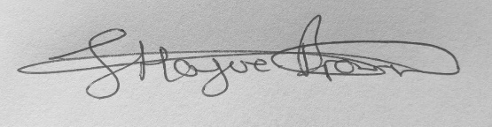
Sam Bailey Ian Bennett Hague-Brown
Executive Principal Chair of Governors

