Post Title: Key Stage 1 Teacher
Reporting to: Executive Vice Principal / Head of School
Salary: MPS
Contract type: Fixed Term – September 2022 until August 2023
Wellspring Academy Trust is a growing Multi-Academy Trust with an increasing number of Academies and ambitions for further growth in future years. We are committed to making a difference to the lives and life chances of the young people and the communities we serve.
Ebor Gardens Primary Academy is at an exciting point in its journey, and we are looking for an exceptional class teacher to join our team and take advantage of the opportunity to work alongside talented colleagues to hone your craft and unleash your potential. We are passionate about offering the very best quality provision in all aspects of the school experience for our little people: we simply believe they deserve nothing less. We have a strong desire to ensure that our children have everything that they need to become successful adults when they leave us. If you are passionate about improving the life chances of young people then this could be the right place for you.
If you are:
- A good teacher who has a thorough understanding of engaging children in Key Stage 1 and eliciting their best.
- Passionate about the achievement of all children and doing ‘whatever it takes’ to secure pupil progress.
- Enthusiastic about your role within a school team who are ambitious for the future.
- Committed to your own professional development.
- A strong team player who enjoys collaboration with colleagues
…then we need you to stay on the team.

What can we offer?
• Fantastic children who bring an abundance of potential.
• A supportive and dedicated team who enjoy high levels of collaboration.
• A consistent approach to curriculum, assessment, teaching and learning, based on the professional collaboration of staff across our partnership of schools
• Brilliant professional development opportunities, from the earliest stages of teaching through to senior
leadership.

If you know that Ebor Gardens is the right school for you – please complete your application and send on to Jeni McCormack, Office Manager, ahead of the deadline.

Wellspring Academy Trust is committed to safeguarding and promoting the welfare of our pupils. All posts are offered subject to enhanced DBS checks. References will be taken up prior to interview. All posts are offered subject Please complete the attached link when submitting your application http://bit.ly/WATEqualOpportunities

If you are currently living overseas or have lived / worked overseas in the last five years please be aware that you will be required to provide an overseas criminal records check from the country/countries you have resided in, if you are the preferred candidate for the post.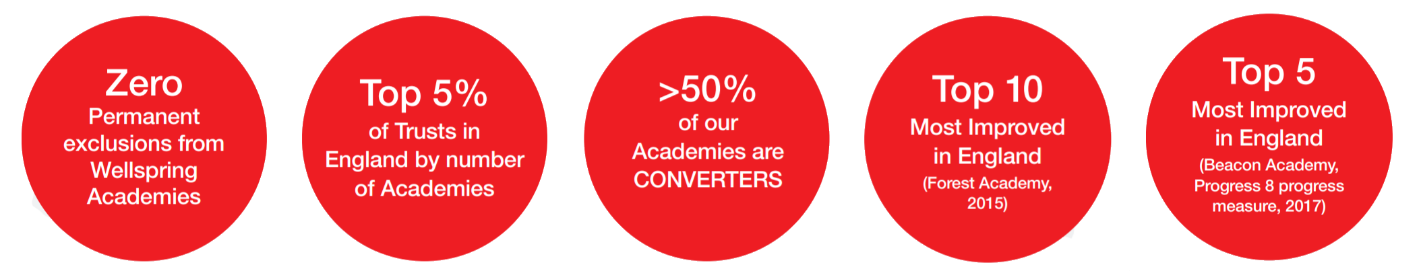

Reporting to | Executive Vice Principal / Head of School
Duration of Post | Fixed Term
Hours | Full-time
Salary | MPS
Start Date | September 2022
Closing Date | Friday 6th May 2022, 12 noon
Interview Date | Monday 16th May 2022
Applications | Completed application forms should be returned to Jeni McCormack jeni.mccormack@eborgardensacademy.co.uk
www.wellspringacademytrust.co.uk

